

West Midlands Cancer Alliance

Management of Systemic
Anti-cancer Therapy (SACT) Induced Diarrhoea in Adult Patients,
v4.0, September 2024

West Midlands Cancer Alliance

EAG name | West Midlands Cancer Alliance Systemic Anti-cancer Therapy (SACT) Expert Advisory Group
Document Title | Management of Systemic Anti-cancer Therapy (SACT) Induced Diarrhoea in Adult Patients
Published date | 30/09/2024
Document Purpose | Assessment and management of Systemic anti-cancer treatment (SACT) induced Diarrhoea
Authors | Nicky Adams, Acute Oncology Nurse Consultant, Walsall Healthcare NHS Trust  Dr V Kunene, Medical Oncologist, University Hospital Birmingham  Dr C Mikropoulos, Clinical Oncologist, University Hospital Birmingham
Review Date (must be  within three years) | 30/09//2026
Approval Signatures: | EAG Chair    Samantha Toland Date: 16/09/2024 | WMCA Clinical Director    Dr Lydia Fresco Date: 30.09.2024

Key Amendments to Document and Version History

Version | Date | Summary of Change/Process
0.1 | October 2010 | Document draft circulated for initial consultation to Chemotherapy Network Site Specific Group
0.2 | October 2010 | Reviewed by Dr Ian Geh Oncology Consultant at Queen Elizabeth Hospital
0.3 | November 2011 | Reviewed and updated by Frances Shaw
2.0 | August 2016 | Reviewed and updated  Walsall Chemotherapy/ Acute Oncology team
2.1 | April 2017 | Reviewed by Nicky Adams (Acute Oncology Nurse Consultant) & Oncologists Dr Mikropoulos / Dr Kunene
2.2 | September 2017 | Further revision following comments from SACT Expert Advisory Group April 2017
2.3 | April 2018 | Further revision following comments from SACT Expert Advisory Group April 2017
3.0 | January 2021 | Reviewed and updated by the West Midlands SACT Expert Advisory Group January 2021.
4.0 | September 2024 | The guideline was reviewed by the West Midlands SACT Expert Advisory Group February 2024.  - The UKONS initial management guideline has been updated.  - Diarrhoea Self-Management – link to the WMCA Common Side Effects of Cancer Treatment web page inserted.  - The guidance on the use of antibiotics has been updated.

Contents

1 Scope | 5
2 Background | 5
3 Guideline Statements | 6
Table 1: Assessment Grading Tool | 6
4 Risk Factors | 7
5 Management | 7
6 Management of diarrhoea due to Irinotecan | 8
7 Patient Information and Counselling | 9
8 References | 10
Appendix 1: Diarrhoea – Initial triage assessment | 11
Appendix 2: Management of Diarrhoea caused by Irinotecan | 12
Appendix 3: Diarrhoea – Immune-related Adverse Event | 13

Scope

This guidance has been produced to support the following:
  - Prevention and management of diarrhoea in adult patients receiving systemic anti-cancer treatment (SACT) including Immunotherapy
  - The guidelines have been revised to incorporate the United Kingdom Oncology Nurses Society (UKONS) Initial management guidelines (Version 4.0, 2023) (Appendix 1) And UKONS 24-hour oncology/haematology Triage (V2 2016)

Background

  - Patients receiving Systemic Anti-cancer therapy (SACT) are at high risk of developing diarrhoea. This risk can be up to 80% with chemotherapeutic agents such as irinotecan and 5-fluorouracil (McQuade et al 2016). This is an unpleasant side effect which will affect the quality of life of a patient and is important that it is treated as effectively as possible.
  - Diarrhoea may also lead to delays in treatment, dose reduction or discontinuation of therapy and the potential for admission to hospital. There is also a small but significant incidence of mortality with SACT induced diarrhoea. Hence it is essential that diarrhoea is treated effectively
  - Watery diarrhoea is commonly associated with Cancer Immunotherapy (27-54%) and symptoms occur within a few days to weeks of therapy (Gupta et al, 2015). Diffuse acute and chronic colitis are the most common findings on endoscopy (8- 22%). Concomitant infectious causes of diarrhoea must be evaluated. Most cases maybe successfully managed with discontinuation of Cancer immunotherapy and corticosteroid therapy. Those with persistent grade 2 and grade 3/4 diarrhoea should undergo endoscopic evaluation and require specialist gastroenterology opinion (see appendix 3).
  - The combination of neutropenia and diarrhoea is potentially extremely serious and mortality risk is high for such a patient
Aims of patient care
    - To minimise patient morbidity and reduce the risk of death associated with SACT induced diarrhoea
    - To encourage patient compliance with treatment through minimising and controlling SACT induced diarrhoea
    - To decrease the need for treatment related dose modification due to SACT induced diarrhoea
Objectives

    - Encourage prompt diagnosis and initiation of treatment of SACT induced diarrhoea
    - Maximise patient quality of life whilst on SACT throughout treatment minimising effects of diarrhoea

    - Ensure patients receive an appropriate management strategy for their grade of diarrhoea. It is vital to read the Drug specific Information Sheet in addition to general diarrhoea guidance

Guideline Statements

Assessment of Diarrhoea

  - Patients should be classified using the UKONS Triage Assessment Grading Tool outlined below
  - Grading of diarrhoea will affect the overall assessment of toxicity for future dose delay or dose reduction
  - Thorough systematic patient assessment is recommended using the revised version of the UKONS Oncology/Haematology 24-Hour Triage Tool (2016). Obtain history of onset and duration of diarrhoea including number of episodes in 24 hours, consistency, colour, associated symptoms, oral intake
  - Consider medication profile including type of SACT, particularly immunotherapy, clearly identify if the patient has been taking laxatives or loperamide
  - Consider dietary profile, to identify diarrhoea-enhancing foods
  - Exclude alternative causes such as infection, bowel obstruction, malabsorption such as with pancreatic cancer, faecal impaction, acute radiation reaction

Table 1 – Assessment Grading Tool (based on UKONS Triage Tool)

Grades | 1 (amber) | 2 (amber) | 3 (red) | 4 (red)
Number of stools / days | Up to 3 bowel movement a day over pre- treatment baseline | Up to 4-6 Episodes a day over baseline | Increase up to 7-9 episodes over baseline | Increase up to 10  Episodes a day
Stool | Loose | Nocturnal stools | Incontinence Nocturnal/ bloody stools | And / or grossly Bloody Stool/ or
Stool | Loose | In case of immunotherapy escalate gr 2 > treat as serious/ potentially life threatening see appendix 3
If Stoma | Mild increase in ostomy output | Moderate increase in stoma output (does not interfere with normal daily activity) | Severe increase in ostomy output (does interfere with normal daily activity) | Requires intensive support/ involvement (risk of haemodynamic collapse)
Symptom |  | Moderate cramping | Severe cramping | Need for Parenteral fluid support

- Risk Factors

Patient factors
  - Older age
  - Female gender
  - Poor performance status > 2
  - Associated bowel pathology such as lactose intolerance
  - Presence of tumour in bowel Therapy related factors
  - Agent specific such as Irinotecan, Capecitabine
  - Cancer Immunotherapy (eg auto-immune toxicity) (For example, Ipilimumab, Pembrolizumab, Nivolumab)
  - Cancer growth inhibitors (TKI’s) Erlotinib, Afatinib,
  - Weekly chemotherapy schedule
  - Infusional chemotherapy
  - Prior history of cancer treatment induced diarrhoea
  - Concomitant abdominal-pelvic radiation and chemotherapy.

Management (see appendices 1, 2 and 3)

  - Interrupt / STOP SACT, including Oral therapy until you have Discussed with the Acute Oncology Team or Oncologist.
  - Immediate fluid replacement/electrolytes plus / IV antibiotics if sepsis suspected as appropriate. Stop ACE inhibitors/diuretics/ NSAIDS / obtain stool sample

Medication

Medication can be used to control the symptoms of SACT induced diarrhoea Grade 1-2:

Loperamide
- Loperamide should be used with caution for patients on immunotherapy; seek specialist advice

- Loperamide should be used where grade 1 diarrhoea lasts more than 12 – 24 hours or for grade 2 diarrhoea; unless patients on cancer immunotherapy where this should be escalated to ‘Red risk’ as action for grade 3-4

- Patients who develop diarrhoea on Irinotecan should immediately start on high dose loperamide unless within the first 24 hours of receiving treatment –see section 6.0

Standard Dose: 4mg initially followed by 2 mg after each loose stool to a maximum 16mg daily

- If diarrhoea persists for more than 24 hours whilst taking standard dose loperamide patients should be commenced on codeine 30-60mg QDS see below.
- Continue loperamide for 12 hours after resolution of diarrhoea but no more than 48 hours in total as risk of paralytic ileus with high dose/prolonged use.

Codeine
Codeine may be added or replace loperamide at the discretion of the physician for grade 1 – 2

Dose 30 – 60mg four times daily (maximum 240mg / 24 hours)

Grade 3-4 diarrhoea consider admission to hospital- follow management for Grade 3-4

Octreotide
  - Where grade 1 and 2 diarrhoea lasts more than 24 hours despite the use of high dose loperamide / codeine then octreotide should be considered.

  - Withhold if not on full maximal anti diarrhoeal medication prior to admission but review every 12-24 hours.

  - Where a patient experiences grade 3 or 4 diarrhoea then octreotide is indicated and the patient should be hospitalized. The octreotide can usually be discontinued 24 hours after the end of the diarrhoea.

Standard Dose 100 – 150 microgram subcutaneously THREE times daily

Consult with Oncologist

If diarrhoea not resolving, broad spectrum antibiotics should be considered (even if afebrile)

Management of diarrhoea due to irinotecan (see also appendix 2)

Atropine - Only used in treatment of early diarrhoea with Irinotecan
  - Early diarrhoea
- Early diarrhoea with irinotecan starts during or within 24 hours of receiving the dose. It is part of an acute cholinergic reaction and is usually accompanied by symptoms such as sweating, blurred visions, eyes and mouth start to water excessively, and the patient feels dizzy and unwell. These symptoms can be controlled using a dose of 0.3mg subcutaneous atropine.
- These symptoms can be prevented with future courses of chemotherapy by the administration of the atropine prior to the dose of irinotecan. A further 0.3mg dose can be repeated if needed within the 24 hour period post irinotecan.

- Patients should not take their anti-diarrhoeal drugs (such as loperamide) within the first 24 hours but should contact their 24 hour advice line with a view to a medical review for the prescription of a second dose of atropine
  - Delayed Diarrhoea
- Delayed diarrhoea occurs more than 24 hours after the dose of irinotecan. The patient should inform their place of treatment and start on appropriate treatment.
- The patient should drink plenty of fluids with electrolytes and the current recommendation is to start on high dose loperamide (4mg immediately then 2 mg every 2 hours to continue until 12 hours after the last loose stool).
- Loperamide must not be taken for more than 48 hours due to the risk of paralytic ileus.

If severe diarrhoea persists longer than 48 hours or is associated with nausea, vomiting or fever patient should be admitted to hospital.

Patient Information and Counselling

Pre-treatment education

  - All patients, and with their consent, their family members/friend should be given access to appropriate written information during their investigation and treatment, and on diagnosis will be given the opportunity to discuss their management with a clinical nurse specialist who is a member of the relevant MDT.
  - Prior to starting treatment patients should be informed that diarrhoea is a potential side effect of cancer treatment , especially with certain drugs and if given in combination with other cancer treatment
  - Patients receiving immunotherapy treatment should be advised to report early signs of diarrhoea as the management for immune-related diarrhoea is different (see appendix 3)
  - Patients should be given advice when it is appropriate to contact the 24hr advice line regarding their diarrhoea.
  - Patients may require nutritional advice and support in order to achieve a satisfactory nutritional status, dietician referral should be considered.
  - Advice on dietary modification during diarrhoeal symptoms should be given: Refer to the West Midlands Cancer Alliance “Common Side Effects of Cancer” web page at Side Effects of Cancer Treatment - West Midlands Cancer Alliance (wmcanceralliance.nhs.uk).

Patients should be advised to report any of the following
    - Increase in frequency and volume (grade 2 or above as per CTC criteria) or relative increase from baseline
    - Mucous in stools
    - Fever associated with diarrhoea
    - Abdominal cramps/pain/bloating (especially for patients receiving vinca- alkaloids)
    - Dizziness

    - Blood in stools
    - Inability to drink adequate amounts of fluid

The patient must have a method of access for 24-hour advice at all times.

      - Patients should be advised to document the frequency and consistency of their stools and monitor their temperature regularly.
      - Patients taking oral SACT Medication must be informed that if they develop diarrhoea that does not settle with loperamide they MUST STOP TAKING ORAL SACT and call the urgent numbers given to them including contacting out of hours emergency contacts.

Patient Advice whilst having Diarrhoea:

Advise patient to:

    - Drink copious amounts of liquid (up to two litres a day) to replace the fluid lost with the diarrhoea, but avoid alcohol, coffee, milk, and lactose products.
    - Eat small, frequent meals made from low fibre foods a BRAT diet can be helpful (banana, rice, apples, toast).
    - Eat meals slowly.
    - Eat less fibre (cereals, raw fruits and vegetables) until the diarrhoea improves. Avoid fried or greasy food, raw vegetables, spicy foods like chilli peppers.
    - Stop laxatives

References

Gupta A, De Felice KM, Loftus EV, and Khanna (2015), Systematic Review: colitis associated with anti-CTLA-4 therapy, Alimentary Pharmacology and Therapeutics, 42 (4)

McQuade RM, Stojanovska V, Abalo R, Bornstein JC, and Nurgall K (2016) Chemotherapy-induced Constipation and Diarrhea: Pathophysiology, Current and Emerging Treatments, Frontiers in Pharmacology vol 7 (414)

UK Oncology Nurses’ Society (UKONS) (2023) Acute Oncology Initial Management Guidelines v4.0, available at: https://www.ukons.org/site/assets/files/1067/ukons_ao_initial_management_guidelin es_final_version_2023.pdf

UK Oncology Nurses’ Society (UKONS) (2016) 24-hour oncology/haematology Triage Tool (V2 2016) available online at: https://www.ukons.org/site/assets/files/1134/triage_tool_poster.pdf

West Midlands Cancer Alliance: Common side effects of cancer treatment, available at: https://wmcanceralliance.nhs.uk/patients-area/side-effects-of-cancer-treatment, accessed 22 February 2024.

Appendix 1: Diarrhoea – Initial triage assessment
(UKONS Initial Management Guidelines V4, 2023, Guideline 6)
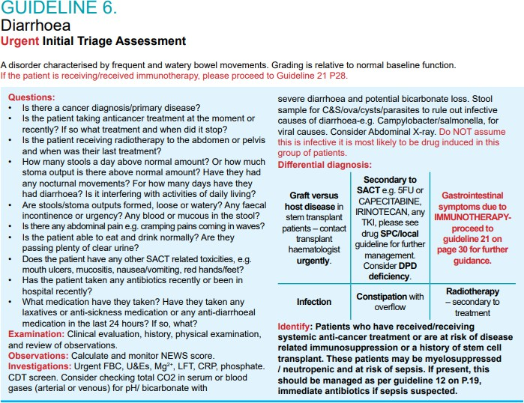
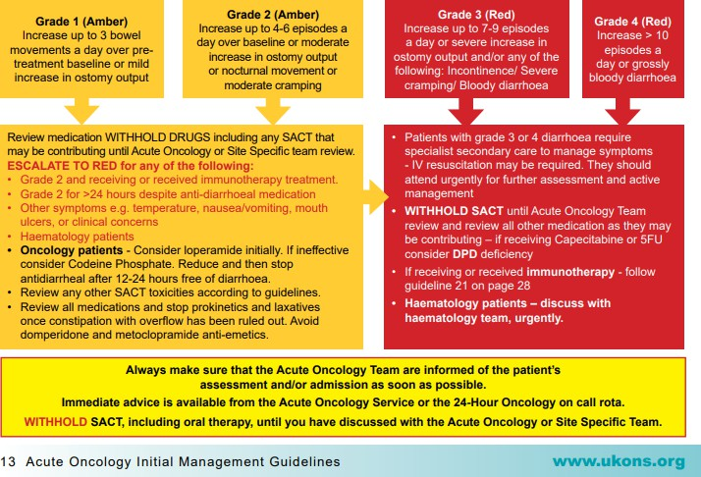

Appendix 2: Management of Diarrhoea caused by Irinotecan

Treatment
Treatment
Increase oral fluid intake
Stool specimen for blood/infection
Start high dose loperamide (4mg stat then 2 mg every 2 h for 48 h)
Dietary Advice

Delayed Diarrhoea (> 24 hours after irinotecan)
Diarrhoea Resolved
Dietary Advice
Early Diarrhoea (< 24 h after Irinotecan)
Acute cholinergic syndrome
First Report of Diarrhoea
(Assess onset, duration and risk factors)
Atropine
Increase oral fluid Intake see 6.1.1Dietary Advice

Review after 12 – 24 h

Diarrhoea Unresolved
If no fever/dehydration/Malena Doctor assessment
Abdominal examination
Stool specimen for blood or infection FBC + U+Es
Increase oral fluid Intake Electrolyte replacement Loperamide 4mg stat then 2mg every 2 hours
Antibiotics where appropriate

Diarrhoea Unresolved
If fever/dehydration/Malena Admit to hospital Abdominal examination Stool specimen
FBC + U+Es
Increase oral fluid Intake Electrolyte replacement IV fluids
Antibiotics

Diarrhoea Resolved
Discontinue loperamide 12 h after resolution. Do not continue beyond 48 hours.
Dietary Advice
Review after 12 – 24 hr

Diarrhoea Unresolved
Octreotide S.C
Consider chemotherapy delay and dose modification
IV fluids, antibiotics and electrolyte replacement as appropriate

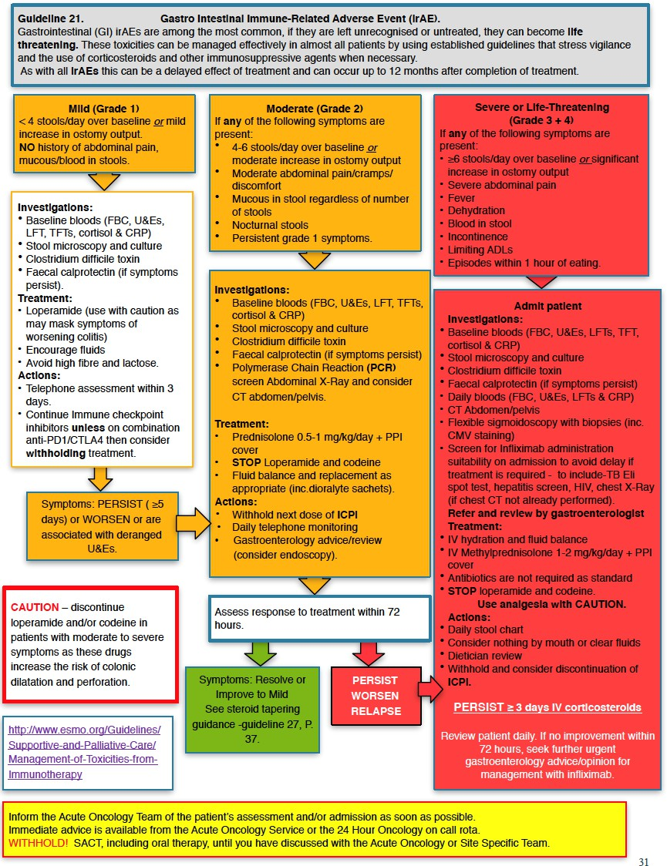
Appendix 3: Diarrhoea – Immune-related Adverse Event (UKONS Initial Management Guidelines)

